Econ DA

Mere perception of secondary strikes wrecks the supply chain.
Christopher Rodenbaugh 23. J.D. from Northwestern Pritzker School of Law, M.B.A and B.B.A. in Finance from Loyola University Chicago. “The Effect of the PRO Act on Secondary Activity and International Trade.” Northwestern Journal of International Law & Business, 43.3, 385-388.
These forms of secondary industrial action have major implications for international trade. In the era of globalization, supply chain networks (SCNs) have grown to monumental proportions, and products as simple as school blazers may have the input of labor and materials from seven or more countries.124 Secondary strikes and hot cargo provisions have a unique ability to disrupt SCNs. During the Strike Wave of 1946, America was brought to a standstill—transportation workers went on strike while freight trains remained idle.125 The ability of secondary strikes to paralyze SCNs is not only the result of striking at the primary company, but of inducing labor actions at companies both upstream (closer to the starting point of production chains) and downstream (closer to the final consumers) of the primary one.126 The magnification of this effect to the scale of global supply networks will likely cause even more significant trade disruptions.
If a “hazard event” such as a strike occurs at a single node of an SCN, it can cause bottlenecking of shipping and production.127 The magnitude of the bottlenecking will depend not only on the size of the company affected but also on its centrality within the SCN.128 Suppose a large number of co-mpanies are dependent upon a particular firm’s manufacturing and shipping. In that case, a strike at that firm can cause their operations to slow or even cease altogether if they cannot find another supplier. Another factor in the magnitude of a strike is how upstream the firm is in its SCN. Bottlenecks due to strikes in more upstream industries can create much more significant effects than strikes in downstream industries because more companies depend on their product.129 For example, a bottleneck in energy commodities or semiconductors can cause industry-wide declines in output that are 3.5 to 4.5 times the size of the initial impact.130 Secondary strikes across company groups can cause much more significant bottlenecking than primary strikes alone. If several companies in a company group are involved in the same industry, a secondary strike at some or all would make it much more difficult for downstream industries to find substitute services and upstream ones to find substitute customers. Secondary strikes could even cause multiple nodes of an SCN to bottleneck if two or more companies in a company group are within the same SCN.
Even the threat of a strike can have significant consequences for production. If labor negotiations begin to sour at a particular firm, other firms in their SCN may anticipate a strike in the future and choose to hoard their inventory of the firm’s product—which can further aggravate supply shortages if a strike is called.131 Further repercussions may be brought by the “bullwhip effect,” which states that when a retailer changes how much of a product it buys, wholesalers can misinterpret the demand signal and overcompensate by ordering even more product from suppliers.132 These companies see a one-off order as an increase in general demand, which will cause them to increase production, causing an inefficiency that will magnify in distortion as it travels upstream along the supply chain.133 The bullwhip effect could cause strike-related hoarding to magnify as it travels through the SCN. Furthermore, substitution orders by downstream firms attempting to find new suppliers may cause those suppliers and their own suppliers to misinterpret the temporary substitution as a demand signal and begin to overproduce as a result. Swings in supply and demand can wreak havoc upon SCNs as firms adjust operations in significant ways to cope with the perceived changing market. Given that many more employers could be exposed to industrial action through secondary strikes, there will be more opportunities for such disruptions.
Just as important is the effect that secondary strikes will have on transnational business groups. Massive transnational companies such as Amazon134 and Google135 can be composed of dozens of subsidiaries with operations across many countries. Legalizing secondary activity in the United States would mean that American workers could engage in industrial action along with workers in other countries with legalized secondary activity, such as Belgium, Sweden, and Italy.136 This means that if the employees of a multinational’s subsidiary in Italy go on strike, then American employees of the multinational’s subsidiary in the United States may also go on strike, picket, or boycott their company or their trading partners.
Recent labor organization efforts at Amazon provide a good illustration of the effect that the PRO Act could have on industrial action. These organization efforts and failed votes, which in general have spurred renewed energy behind the PRO Act, have outlined the difficulties associated with unionization.137 These difficulties can be compounded by fissured workplaces in which potential bargaining units may only be able to negotiate with their direct employers, who themselves are constrained by their contract with the lead business.138 Secondary activity, in particular, adds to the tools available to Amazon workers, as it can allow them to engage in actions such as encouraging strikes among subcontracted and subsidiary workers across the globe while also removing Section 8 barriers to their free speech. Workers may also decide to engage in picketing or boycotting of companies upstream and downstream of Amazon on its supply line, causing severe bottlenecking in Amazon’s operations.139 Hot cargo provisions can further bolster union power. If nearby Amazon warehouses go on strike, unaffiliated transportation workers can refuse to carry Amazon packages so long as such a provision is included in their collective bargaining agreement. All these actions would heighten the pressure on Amazon to settle on the union’s terms.
These strategies could be deployed against any firm in the United States—even those that may not be able to survive the economic effects. Secondary strikes will doubtlessly lead some businesses to close their operations, as has resulted from primary and sympathy strikes such as those at Hostess Brands and Eastern Airlines.140 However, even these closures were not brought about solely due to labor strikes but by larger market forces and an inability to adapt. In the case of Hostess, consumer tastes changing away from junk food made the company fatally outdated.141 Rather than shifting to more profitable operations, the company decided to severely cut wages and benefits, which Forbes contributor Adam Hartung described as “tantamount to management saying to those who sell wheat they expect to buy flour at 2/3 the market price.”142 Thus, putting more tools at the disposal of unions may ultimately create a greater drive in American capitalism toward efficiency and adaptation. The risk of closure was even an acknowledged effect of the New Deal slate of legislation; in fact, President Franklin Roosevelt stated that “no business which depends for existence on paying less than living wages to its workers has any right to continue in this country . . . . [A]nd by living wages I mean more than a bare subsistence level—I mean the wages of decent living.”

Greenlighting secondary strikes causes economic destruction
Michael Watson 23. Research Director for Capital Research Center and serves as the managing editor for InfluenceWatch. "In Defense of Taft-Hartley: Protecting the Public." Capital Research. 10/17/2023. https://capitalresearch.org/article/in-defense-of-taft-hartley-part-4/
Protecting the Public from Labor-Dispute Fallout
The past few years should be an object lesson in why the Taft-Hartley principles limiting unions’ power to disrupt commerce and society—remember the parade of horribles that President Truman detailed during the 1946 railroad strike—should be toughened, not weakened.
The Biden administration and its Democratic allies in Congress have advanced the Protecting the Right to Organize Act, a broad-based repeal of the Taft-Hartley model that among other things would lift limits on “secondary boycotts” by labor unions. Conservatives should be extremely familiar with the secondary boycott: It is plausibly described as “the Left’s ultimate weapon.” First, a definition:
A “secondary” boycott differs from a traditional boycott in which entity suffers the activists’ pain. A traditional “primary” boycott (or primary strike, primary picketing, or other primary action) targets the actor whose behavior the activist wishes to change. . . . The business under boycott is the activists’ target—the pressure is directed at the actor whose behavior the activists wish to change.
Secondary boycotts have different direct targets. The activist targets a victim with the intent of changing the behavior of a third party with whom the victim engages, usually in a commercial transaction.
The goal of the secondary boycott is to coerce the principal target by getting the third party being boycotted to compel the primary target to do the activist’s bidding. Left-wing groups like Media Matters have employed secondary boycotts to advance left-wing social policy and silence conservatives even before the rise of cancel culture. Big Labor would surely love to gain the power to coerce businesses that it has dragooned into collective bargaining into compelling suppliers to complying with DEI demands, LGBT Pride product placements, and abortion-access regimes that Big Labor prefers.
By now, anyone with eyes to see should be disabused of the notion that contemporary labor unions are “purely industrial or economical class organizations with less hours and more wages for their motto.”
Under the COVID-era lockdown regime, teachers unions extensively illustrated to the public the consequences of giving labor unions unlimited power to disrupt society. Teachers’ unions explicitly, without fear of governmental reprisal, demanded that the police be defunded, charter schools be banned, and illegal immigrants be given government benefits as a condition of reopening schools that were ostensibly closed due to COVID-19. Teachers unions denounced reopening schools as “rooted in sexism, racism, and misogyny” while their board members vacationed in the Caribbean. When America’s children needed a firm, Taft-Hartley response, the world wondered. The consequences of that failure are only beginning to be learned.
Teachers unions were not alone in their work to disrupt the social world in the name of union power. In New Jersey, the United Food and Commercial Workers praised lethargy in lifting mask mandates. The Association of Flight Attendants, a division of the Communications Workers of America, demanded that the public-transport and airplane mask mandate continue. (The mandate was only ended by order of a federal judge in April 2022.) If unions had gotten their way, the COVID-era mandates might have been codified into law through OSHA rules.
The cowardice of public officials, conservatives as well as liberals, in the face of union demands during the COVID era starkly contrast with the proper response to organized labor taking a (metaphorical) gun to the head of the economy and society. Truman detailed it in his speeches against the 1946 railroad strike, and responded by threatening to draft the railway men into the military. Ruining the public in the name of a union benefit cannot be permitted.
President Ronald Reagan carried out the proper response when the air traffic controllers union—which had endorsed his campaign in 1980—struck in violation of federal law in 1981. In keeping with the Taft-Hartley consensus, President Reagan forbade the Professional Air Traffic Controllers Organization from extorting the traveling public by shutting down commercial air travel: He fired those who struck. Ruining the public in the name of a union benefit was not permitted.
It is one thing for a labor organization to strike against its employer to jawbone the employer to make concessions. In the private sector, this is both customary and legally protected. But granting organized labor—either by negligence of duty as with teachers during COVID or by design as with the proposed restoration of the secondary boycott—more power to coerce the public ought to be anathema to conservative policymakers. Any labor-relations policy change they consider should be considered in light of the coercive power unions demonstrated willingness to abuse. After all, in the immortal and infamous words of United Teachers Los Angeles president Cecily Myart-Cruz: “Our kids didn’t lose anything. It’s OK that our babies may not have learned all their times tables.”
Such perfidy must not be repaid with greater power.
Here We Must Stand
Over the 76 years since the passage of the law bearing the name of “Mr. Republican,” organized labor has done absolutely nothing to disabuse conservatives of their skepticism of it. Indeed, labor unions have moved even further to the left in recent decades as private-sector unionists who rose through the ranks at the bargaining table have been replaced in labor movement leadership by government-worker unionists who rose through the ranks of left-wing political activism.
Given that, abandoning the Taft-Hartley consensus principles and the policies that they inspire to instead:
- Give power to compel unionist activities and funding,
- Lift disclosures on union finances and to expand the discretionary power of ESG-inspired union pension-fund managers, and
- Give labor unions the power to threaten widespread economic destruction in order to secure labor’s hard-Left non-economic aims
would be a blunder worthy of the Romans at Cannae or Teutoburg Forest, the Confederates at Gettysburg, or the Russians at Tsushima. Here we must stand.
The alternative is political and economic destruction.

Collapse causes extinction
John Braithwaite 24. The Australian National University, Acton Simple Solutions to Complex Catastrophes, Sustainable Development. Chapter 2 “Rapid Cascades, Coupled Crises”. Chapter Open Access First Online: 27 February 2024 pp 9–49. Accessed via Emory Libraries.
Complexity of risk is something modernity accelerates. So is coupling of risk from one kind of crisis to another kind, and speed in the globalization of crises. Crises today cascade faster into one another. This is true of economic and ecological crises, the globalization of disease, and security crises. Crises develop increasingly rapidly because of accelerating innovation in global capitalism. Social media platform innovation accelerated the rapid spread of lies to the point of outpacing older, simpler institutions for the proliferation of truths. This includes lies that motivate new forms of dangerous behavior like advocating a coup to put right an allegedly stolen election, or the lie that war can be waged to sustain a new Caliphate to conquer the Middle East and Africa.
Improved professionalization in the proliferation of falsehoods led to election of climate change deniers during the very period of history when it became too late for fully effective catastrophe prevention. New technologies of cyberwarfare, cybercrime and cyberterrorism, new space warfare by electromagnetic and cyberspace technologies, and new ways of disabling them in space, may cascade to horrific hails of space wars. Coupled cascades put us at risk from cyber-threats that tip security systems toward cascades of nuclear weapons use by accident, miscalculation, or linkages to faulty technologies.
Russia, China, and the United States may not be far from capability for multiple forms of Mutual Assured Destruction (MAD), not only MAD by nuclear weapons, but also Mutual Assured Digital Destruction (MADD) through digital time bombs planted, ready to explode on demand, in electricity grids and other systems that serve nuclear weapons targeting, hospitals, telecommunications, and more. They would explode with malware designed to activate during a crisis. No one knows how advanced great powers are in achieving MADD capability. Only technological pessimists could think that while kinetic MAD is within their grasp, cyber MADD never will be.
The June 27, 2017 cyber-attack on Ukraine by Russia turned Ukrainian screens black everywhere. Money could not be withdrawn from ATMs. Ukrainians could not be paid, send or receive mail, pay at gas stations, or buy a train ticket or groceries. Worse, Ukraine could not monitor radiation levels at Chernobyl and Zaporigia. This combined with effects on hospitals rendered the cyber-attack a war crime against humanity. NATO-based companies with major operations in Ukraine were also devastated. Merck and Fedex alone were hobbled at a cost of $1 billion as the Russian malware infected their worldwide communications (Perlroth 2021, 18). A couple of years later, before and after covid and when Ukraine staggered from an unprecedented measles outbreak, Russian trolls surged anti-vaccination dogmas across Facebook accounts of young Ukrainian mothers (Perlroth 2021, 19). War cascaded to escalated epidemic severity.
Russia also attacks NATO states with anti-vaccination messages intended to cause health harm, but more fundamentally to sow division in ways that intersect with other cleavages based on politics, race, neoNazi belief systems, class, and religion. Other states target Russia and China in the same ways; others target this kind of sowing of internal divisions against Israel; Israel in turn sows divisions among Palestinians and Iranians. From unimagined sources seeds are sown for future fascism and war. The argument of this book is that restorative diplomacy, genuine healing among old enemies, is the fundamental solution to this problem that has worked again and again throughout history in persuading old enemies against future meddling in one another’s domestic politics. It is just that restorative prevention and healing are more imperative than in the past, during an era when cyber operations are almost totally undeterrable and do such great crime and war harm that is extremely difficult to prevent technologically. Cybercrime is already the most common and damaging form of property crime for these reasons (Braithwaite 2022); soon cyberwar could become the most harmful form of warfare when the first case of Mutual Assured Digital Destruction turns all the screens black on both sides of alliances fighting a large war.
Russia would be better off had it restored diplomatic relationships with NATO states so they stopped meddling in Russia’s internal affairs, ended financial sanctions against Russia, ceased costly proxy warfare against Russia to defend Ukraine. The United States would be better off had it not provoked Putin to meddle in US politics without which Donald Trump would have been defeated by Hilary Clinton in 2016 (Levin 2020). That meddling has been so effective in dividing Americans against one another that even a coup against an elected government could be attempted. It has been effective in stoking fires of neo-fascism in America, in costing US companies losses as high as a billion dollars from Russian hacks, in causing US taxpayers to suffer an inflation shock and the loss of trillions of dollars preparing Ukraine for war only to see its ally lose big chunks of its territory. A continuation of great power politics as usual is a lose-lose game compared to restorative diplomacy that heals the hurts that motivate all these crimes and weakens both great powers vis a vis China (Chapter 8).
Mutual Assured Destruction capabilities with the satellite communications that allow aircraft to land, and other critical forms of communication may not be far off. Russia and China can already destroy the coupling of financial systems and the internet between Europe and the United States. Subsea cables are responsible for 97% of the data and information flows of transcontinental communication and finance (Acharya 2023). Enemies can cut cables somewhere along a vast ocean floor without being detected. Early in 2022 when Russian President Putin was rattling his nuclear saber, Britain and NATO messaged that cutting submarine cables would be ‘an act of war’ (Bone 2022).
This is an example of chokepoint deterrence because there is little prospect this century that humankind could build the number of satellites that would be required with the bandwidth of what cables can do. Russia cut trans-Atlantic cables on a number of occasions during milder crises of the Cold War. Repairing them can take weeks; then they can be cut again. Or Russia could then follow up by cutting another between the United States and Japan/Korea. The United States could reciprocate. Russia is coupled by cable to a lot less wealth than could be destroyed via the coupling of the United States with Europe or Japan. The coupling most vital to Russia since the war in Ukraine commenced is to China and its allies, not vulnerable cable connections across vast oceans. Google is doing it alone to build its own undersea cable to link its North and South American operations and data centers. This may be an attractive Russian escalation target along some future Russian trajectory to threatening MADD—with few Russian companies traveling that line. MADD by this means requires cutting many cables at once because single cuts can be re-routed along an alternative line, though with significant cost. Something that may have protected the West from the concerted attacks on undersea cables may be that China is a big player in the telecommunications and subsea cable industry. On the one hand, that is not much of an assurance perhaps for a future war with China, backed by Russia. On the other hand, this is another instance of how economic interdependence retains the potential to motivate peacemaking.
Coupling makes us wealthier and more capable of solving problems. Yet the more coupled, the more vulnerable we are. This book argues that because we can no longer ‘contain’ our enemies from cutting our coupling, nor they contain us from cutting theirs, there is no choice but to get better at turning enemies into friends. We can beat cyberbombs into cybershares that plough furrows of digital and quantum cooperation. We must beat nuclear bombs into nuclear fusion that we share to solve our mutual climate and energy crises. Fear of MADD can motivate the peace movement to educate us on where to seek shelter inside buildings when a nuclear mushroom cloud appears on the horizon. It is a mistake to think that messages on what to do will appear on our screens and airwaves; they may all turn blank at the moment the mushroom appears.
Hence, a second fundamental of this book is that rapidity of change is compounded by the tightly coupled character of crises. As Warren Buffet said of the international economic crisis in 2008, risks today are more coupled than in the past, so the collapse of a US bank more readily cascades to collapse of European banks. This is a fact of life. It is also a fact that we become wealthier as banks sell to one another. Bank dominoes fell at first because they were infected with securitized US subprime loans that were bad loans; in no time banks were collapsing because other banks were. Banks did not know how infected with bad loans other banks might be. So they stopped trusting them. This bleeding rapidly congealed the lifeblood of interbank lending.
A tipping point toward systemic collapse was passed when interest rates on risky interbank lending became so high that banks were stuck with bundles of mortgages in good loans. They were unable to sell them to prop up their liquidity. They could not pay their debts. The only line of credit they could access was taxpayer bailout. Risk therefore became both more complex and more systemic. Systemic risks are risks that result in crises of whole systems, as opposed to breakdowns of bits of systems. Systemic risk means that collapse of one bit of a system cascades to many bits infecting other bits with catastrophe. In contemporary risk societies (Beck 1992) characterized by compressed space–time (Harvey 1989) and just-in-time logistics for ensuring that all capital is at work rather than tied into inventory, risk complexity can cascade quickly to systemic global crises.

Impacts Defense – 2024 (Labor Neg Cora)
- Automation

Prefer macroeconomic metrics over microeconomic distortions---automation is deflationary, generating real income gains that spur new employment. Err neg cause new jobs have empirically been unknown at the start.
Philipp Carlsson-Szlezak & Paul Swartz 24. BCG's Global Chief Economist and Managing Director, leader of the Center for Macroeconomics at the BCG Henderson Institute. Senior economist and executive director in Boston Consulting Group. “Why AI will not lead to a world without work.” Centre for the Fourth Industrial Revolution, 1.1.
Technology, including artificial intelligence (AI), must be deflationary to have a macroeconomic impact. It can reduce costs and prices and boost real incomes and demand, thereby creating new jobs and offsetting automation-driven losses.
Predictions of technological unemployment have repeatedly proven false, as macroeconomic job creation in new sectors offsets microeconomic disruptions.
AI is likely to increase productivity and wealth, with new jobs emerging; the focus should be on managing sector-specific disruptions, not fearing labour market dystopia.
In 1983, Wassily Leontief, a Nobel Prize-winning economist, concluded that human labour would go the way of the horse after the automobile arrived – “first diminished and then eliminated.”
Today, a new wave of doomsaying has emerged surrounding “technological unemployment” as AI, with its promise of business innovation, has marched to the forefront of economic debate. Pundits argue we’re now drifting towards a “world without work” where machines produce all things and algorithms provide all services. Outclassed humans serve no role in this macroeconomic dystopia.
As we argue in Shocks, Crises, and False Alarms, predictions of technology-driven job destruction have a long history and correspondingly, a long record of failure. Angst about worker obsolescence ebbs and flows with each new generation of technology. The threat from automation was once deemed so dire that Bill Gates proposed a “robot tax” on companies choosing robots over human labour to soften the blow of its impact on workers.
Yet, amid relentless technological progress over the past 80 years, during which the labour market has been remade – and then remade again – the US economy has added 120 million jobs. In 2024, as the unemployment rate remains historically low and real wages are growing, few remember Gates’ robot tax idea.
The deflationary nature of technology
Though it remains a popular narrative today, the failed predictions of technological unemployment have not been lost on all economists. More upbeat assessments contend that AI will augment workers – perhaps the least-skilled ones – rather than replace them. Others argue that replacing workers is harder than it seems because jobs are collections of tasks and AI may not be able to do all of them seamlessly.
Such arguments are important and rooted in the microeconomics of work. However, macroeconomics offers the most persuasive arguments against mass unemployment in the face of AI.
What is routinely overlooked is that technology is an inherently deflationary force. When it is broadly impactful, technology drives down costs and prices, pushing up consumers’ real incomes and demand for new goods and services – and thus, new employment. A matter of logic more than luck, such rejuvenation of the labour market has occurred repeatedly.
Perhaps the most powerful demonstration of technology’s deflationary benefits has occurred with food. In the late 19th century, nearly half of all Americans worked on a farm and spent more than 40% of their disposable income on food. Over the subsequent 150 years, successive waves of innovation have left but roughly 1% of Americans working on farms. Food budgets, meanwhile, have fallen to roughly 12% of income.
<<IMAGE OMITTED>>
Lower prices deliver what economists call real income gains – consumers spend less and use the extra room in their budgets to increase consumption of, often new, goods and services, ultimately leading to new employment. Yes, the process has always come with sector-specific job losses and thus microeconomic pain but it has also served as a reliable route to new jobs and macroeconomic gain.
With such a record of failure, it may seem surprising that doomsayers cling to dystopian narratives of technological unemployment. But it is easier to spot technology-driven job losses, which are often concentrated and can happen fast than it is to discern new job creation, which is usually dispersed and happens over time.
Will AI buck the trend?
If we scrutinize AI’s promise along each step of the well-trodden path from new technology to new employment, it seems unlikely that AI will end a history of labour market rejuvenation and adjustment.
Cost reduction. AI is likely to succeed at replac[e]ing labour, particularly in services where digital technologies have struggled to do so in the past. Though the speed and size of this impact are likely to be more modest than many expect today, gradual and cumulatively significant cost reduction (and productivity growth) is a safe bet.
Falling prices. Unless labour-saving technology can be monopolized, it will continue to drive cost competition and deflation. Far from being specific to food production, the effect has been seen in manufactured goods and now looks set to unfold in services. Policymakers may need to watch for and ensure competitive market structures to ensure that AI becomes a deflationary force in the economy.
New demand. Real income gains often drive demand for goods and services that were barely known when a new technological wave began (few would have foreseen the arrival of social media marketers a few decades ago). This demand effect could fall short if consumers retreat and save their income gains. However, the resulting savings glut seems unlikely and directly contradicts the historical record.
New employment. What if a machine or an algorithm can always meet new demand? That humans lose all comparative advantage seems remarkably unlikely. AI’s labour-enhancing properties are as credible as its labour-eliminating ones. But even if Leontief’s words turned out prescient and humans went “the way of the horse,” that would hardly amount to a macroeconomic dystopia. Instead, the overwhelming deflationary impulse would lay the ground for unparalleled prosperity.
The impact of AI will be seen, experienced, and reported primarily through a microeconomic lens that magnifies the disruptions and gyrations that will come. That should not be conflated with the macroeconomic promise that AI holds. Mass technological unemployment remains an ahistorical and unlikely proposition. AI does come with important risks but pervasive joblessness should not top our list of concerns.

The only reason we haven’t seen further-reaching bans on AI is because unions lack bargaining power. It’s what every union wants.
France 25. International News Network. “US labor unions fight to contain AI disruption." 4/6/2025. https://www.france24.com/en/live-news/20250604-us-labor-unions-fight-to-contain-ai-disruption
Vetoes
The Teamsters union is backing legislation limiting the spread of automation, despite which governors in California and Colorado have vetoed bills that would ban autonomous trucks from public roads
The Teamsters have focused their efforts on passing legislation limiting the spread of automation, but face significant political obstacles.
California's governor has twice vetoed bills that would ban autonomous trucks from public roads, despite intense lobbying from the state's hundreds of thousands of union members.
Colorado's governor followed suit last week, and similar battles are playing out in Indiana, Maryland, and other states.
At the federal level, the landscape shifted dramatically with the change in the White House.
Under former president Joe Biden, the Department of Labor issued guidelines encouraging companies to be transparent about AI use, involve workers in strategic decisions, and support employees whose jobs face elimination.
But US President Donald Trump canceled the protections within hours of taking office in January.
"Now it's clear. They want to fully open up AI without the safeguards that are necessary to ensure workers' rights and protections at work," said HeeWon Brindle-Khym of the Retail, Wholesale and Department Store Union (RWDSU), which represents workers in the retail sector.
Rush to AI
Meanwhile, companies are racing to implement AI technologies, often with poor results.
"By fear of missing out on innovations, there's been a real push (to release AI products)," observed Dan Reynolds of the Communications Workers of America (CWA).
The CWA has taken a proactive approach, publishing a comprehensive guide for members that urges negotiators to include AI provisions in all collective bargaining agreements.
The union is also developing educational toolkits to help workers understand and negotiate around AI implementation.
A handful of unions have successfully negotiated AI protections into their contracts.
Notable examples include agreements with media company Ziff Davis (which owns Mashable) and video game publisher ZeniMax Studios, a Microsoft subsidiary.
The most significant victories belong to two powerful unions: the International Longshoremen's Association, representing dock workers, secured a moratorium on full automation of certain port operations, while the Screen Actors Guild (SAG-AFTRA) won guarantees that actors must be consulted and compensated whenever their AI likeness is created.
These successes remain exceptional, however.
The American labor movement, as a whole, lacks the bargaining power enjoyed by those highly strategic or publicly visible sectors, said Brindle-Khym.

Automation is coming now, but empowering unions wrecks it because they perceive it to be labor-market disrupting---that slashes growth AND ensures Chinese leadership. Independently, it won’t be job displacing AND productivity gains offset job losses.
Robert Atkinson 25. Member of the Panel on the State of Science, Technology, and Innovation in Canada at the Council of Canadian Academies, Member of the Polaris Council, providing science and technology advice to the GAO, Ph.D. in City and Regional Planning, M.A. in Urban and Regional Planning. "Why America Must Embrace Job-Killing Technology." Policy Arena. 6/5/2025. https://www.policyarena.org/p/why-america-must-embrace-job-killing
Many now treat job automation as a human rights violation. Displacing workers with technology is seen as cruel and unusual punishment, a plot by selfish capitalists to enrich themselves at the expense of the victimized masses.
This soft, self-centered, and socialistic narrative is an anchor weighing down U.S. economic growth and global competitiveness.
Calls to limit automation “crimes” are broad. Unions increasingly resist automation. The Screen Actors Guild went on strike in part to demand protection from AI doing some of their work. Dockworkers, too, are waging a battle against automation.
Even many economists now flirt with neo-Luddism. Paul Krugman, who once wrote that productivity is “almost everything,” recently argued, “We need to protect human workers” from AI automation. Nobel laureate and MIT economist Daron Acemoglu wants the government to tax automation. And two economists writing for the National Bureau of Economic Research even propose that government policy should cut the already anemic rate of automation in half.
The anti-automation sentiment is bipartisan. Progressive pundit Robert Reich claims, “The rush to automate is creating a crisis of unemployment and inequality.” Former Obama economic adviser Gene Sperling sees AI and similar technologies as “threats” to workers. Democratic presidential candidate Andrew Yang calls automation a “war on normal people.”
Seeking to outbid the Dems’ anti-automation fervor, the new right has followed suit in its attempt to rebrand the GOP as the party of the working class. Senator Josh Hawley (R-MO) warns that “tech giants are replacing American jobs with automation while claiming it’s progress.” Vice President J.D. Vance declared in 2023 that “Silicon Valley's rush to automate everything threatens the dignity of work." A recent open letter from numerous prominent “family conservatives” called for “technologies that enhance human skill and improve worker satisfaction over those that degrade or replace human labor.”
Even MIT Technology Review—once a gospel of tech progress—ran a cartoon stating, “Opposing technology isn’t antithetical to progress.” It even suggested violence: “Welcome to the Future: Sabotage It.” Meanwhile, the National Academy of Engineering now claims that the only good automation is that which creates more jobs in the same company deploying the technology.
But let’s be clear: While some workers may get hurt by automation, all consumers of the organization benefit through lower prices and improved products. But apparently—nope, that is not enough. No one is allowed to be hurt, ever.
This shift is new and deeply disturbing. The American ethos once embraced automation as a central component of progress. In the 1930s, economist Benjamin Anderson warned, “on no account must we retard or interfere with the most rapid utilization of new inventions.” In 1952, presidential candidate Adlai Stevenson celebrated automation, declaring that the United States at mid-century stood “on the threshold of abundance for all.”
So, what changed?
Some argue that this time is different—that the rate of automation is too high and the pain being inflicted is too great. However, job losses due to downsizing or closures are at their lowest level since 1995. Historical data shows that rates of job loss due to automation were significantly higher in the late 19th and early 20th centuries, and Americans widely supported technological advancement, such as automation, during that time.
Others claim that workers no longer benefit from automation-induced productivity gains. But as we showed in Technology Fears and Scapegoats, government data does not support that argument.
In reality, I believe the calls to “destroy the machines” reflect a broader transformation of American culture and values—from honoring risk-taking and tenacity to prioritizing comfort and codling. The new societal ethic is that a good society is a painless one.
Pundits, activists, journalists, academics, and policymakers now demand that everyone be protected from any form of psychological discomfort. To remain in polite company, one must decry automation or risk being labeled patriarchal, capitalistic, or heartless.
But was it heartless to replace gas station attendants with self-serve pumps? Was it cruel to eliminate airline counter staff with self-check-in kiosks? Was it capitalistic to install ATMs nationwide?
All of these “crimes” boosted productivity, raised living standards, and freed up workers for better jobs. These innovations allow the United States economy to do more with less. And history shows that those laid off typically found new employment. Indeed, a substantial body of research confirms that automation increases productivity without leading to increased long-term unemployment.
So, call me heartless, but nothing would make me happier than seeing 50 percent of American jobs automated over the next decade or so. That kind of transformation would double living standards for my (and everyone else’s) children.
Until U.S. culture starts accepting that short-term individual discomfort is the sine qua non of progress, America will continue to decline, at least in relative terms. Automation and displacement equal progress.
This is, at its core, a debate on ethics. English philosopher Jeremy Bentham argued for the greatest good for the greatest number of people, which is precisely what automation delivers. However, today’s prevailing ethics are rooted in the work of redistributionist philosopher John Rawls, who insisted on protecting the least advantaged, even at the expense of overall progress.
Rawls wrote that the goal should be “maintaining conditions and achieving objectives that are similarly to everyone’s advantage.” There can be no automation in a Rawlsian world, because even if 99.999 percent of society benefits, 0.001 percent is harmed. Under this moral framework, creative destruction becomes unethical—and growth extremely difficult.
This ethical shift distorts how we define the public interest. In their growing anti-capitalist animus, both the progressive left and the populist right equate public interest with the interests of workers. For example, the Center for American Progress recently published an article titled “Will AI Benefit or Harm Workers?” But why are workers the central concern? What about children, students, consumers, retirees, business owners—or even those who don’t work in automatable roles? The reality is that society consists of many interests, and privileging one group above all of us is a recipe for stagnation.
Relatedly, it’s now fashionable to reject corporate interests, arguing they conflict with the national interest. It was once assumed that large firms were at least somewhat aligned with the national interest. Many folks thought, “Sure, companies want to make money. Nonetheless, they boost productivity and create new goods and services.”
Today, large companies are cast as villains, driven solely by selfish, capitalist interests. As the National Academy of Engineering writes, “The purpose of a corporation is to create shared value, not just profits… The key is to implement measures that enable everybody to benefit from these transformative technologies and turn AI and automation into forces for shared prosperity.”
But in a functioning market, firms already create “shared value.” If they develop new goods and services that consumers voluntarily buy, they’re, by definition, creating value. Public policy can and should address negative externalities like pollution, but beyond that, firms don’t need to be reengineered as moral agents.
What’s especially troubling about this framing is the idea that scientists and engineers should serve as ethical gatekeepers, determining which technologies are “worthy” of development. That’s not their job. If they want to do that, they should start their own company and see if they can make a profit. No, their job is simple: Discover, create, and push the frontier, even and especially if that means the technology is used to automate tasks and replace labor. Deciding what innovations get deployed and how is up to society as a whole, not individual technologists playing God.
P.S. Just to be clear, supporting automation doesn’t mean the government should abandon laid-off workers. The U.S. system for helping displaced workers needs serious improvement. But that’s a reason to fix retraining and support programs, not to reject technological progress.
The sad reality is that America has grown soft, selfish, and socialistic—distrusting for-profit companies and rejecting discomfort. Everyone gets a trophy for participating, and no one can be cut from the team. That’s a sure path to stagnation and decline, not to mention ceding our manufacturing future to China. It’s time for America to become hard, patriotic, and capitalistic again. That means not just tolerating automation but embracing and accelerating it.
Maybe in 50 or 100 years, once we’ve secured a higher standard of living and no longer face intense global competition, we can afford to indulge in comfort. But not today. Embracing the three S’s—softness, selfishness, and socialism—is national suicide.

Trump is fine.
Michael Hirsh 24. M.A. in International and Public Affairs from Columbia University. “Yes, Biden Flopped. But Let’s Not Overreact.” https://foreignpolicy.com/2024/06/28/biden-trump-presidential-debate-performance-democracy-us-world-leadership/
Why? The United States continues to be the unchallenged superpower, with China and Europe flagging economically and Russia mired in an utter disaster in Ukraine. Yes, Trump is the most successful demagogue in U.S. history—the fulfillment of all the fears that swirled around previous would-be authoritarians such as Aaron Burr and Huey Long in their heyday.
A second Trump presidency may well mean that Abraham Lincoln’s “mystic chords of memory”—the honored traditions keeping the republic intact—will be strained to the breaking point. Internationally, it may also mean a bad peace deal for Ukraine, an existential challenge to NATO, a renewed trade war with China, and possibly much worse.
But the republic will survive—and more handily than one might think. Trump is 78 himself and can’t go on indefinitely. The courts and the checks and balances in the system are still strong enough to fight off his worst authoritarian impulses.
And one thing Trump said Thursday was actually true: He didn’t start any wars in his four years as president. Trump would probably not just pull out of NATO; he and his advocates are already spinning the pledges of additional spending by NATO allies as a victory. He may cut a deal with Russian President Vladimir Putin to end the Ukraine war, but many people on both sides believe some sort of compromise is necessary anyway.
The Europeans and Japan will stick by Washington no matter what: Even though many pundits predicted doom for the United States throughout the Trump era, Europe only fell further behind. As Fareed Zakaria wrote in the Washington Post recently, in less than 20 years since the 2008 Great Recession (started, by the way, due to huge political errors by Washington), the U.S. economy has gone from being roughly the size of the eurozone to nearly twice as big.
“The U.S. economy towers above Europe’s these days,” Zakaria wrote. “The United States’ technology companies dominate the continent. U.S. banks are far more profitable than European ones. U.S. energy production has created a boom in manufacturing which is luring many European companies to the United States.”
Of all the false things Trump said during the debate—and there were dozens—the most absurd was this: “Throughout the entire world, we’re no longer respected as a country. … We’ve become like a Third World nation.” It may look and feel that way in Washington, but it doesn’t elsewhere.
Moreover, the harsh exchanges between Trump and Biden belie the fact that on many issues related to America’s place in the world—trade, immigration, China, neo protectionism, and the new “make it in America” fervor that has overtaken both parties—they agree about a lot, if not everything.
Trump repeatedly attacked Biden for the ugly and humiliating way the president pulled out of Afghanistan, but it was Trump who set in motion the policy to sidestep the Afghan government and negotiate directly with the Taliban, which led to the disaster. And Putin and Chinese President Xi Jinping—who have more or less joined forces to try to eclipse U.S. hegemony—have their hands full with their own domestic problems.
Among the many awful moments of the debate, both Trump and Biden—an ex-president and a current one—accused the other of being the author of imminent disaster. “He will drive us into World War III,” Trump said. Biden responded: “You want World War III? Let [Trump] win, and let him tell Putin to do whatever the hell he wants to NATO.” Neither scenario is likely to happen.
Much of the debate in Washington over the next several days will focus on renewed efforts by Democratic Party grandees to persuade Biden to step aside for a younger person. This will very likely not happen, either. As one longtime politics maven told Politico Playbook, Biden is “not going to step aside and there is no clear process for replacing him. So we’ll have a few days of frenzy. Then everyone will realize the main contours of the race haven’t really changed.”
What also hasn’t changed is that the United States has been through far worse turmoil than this. As historian Doris Kearns Goodwin wrote in her most recent book, An Unfinished Love Story, quoting her late husband, the legendary presidential speechwriter Richard Goodwin, “The end of our country has loomed many times before. America is not as fragile as it seems.”

3 – Taiwan War

Analytically – this doesn’t solve – railrays won’t be main point of attack – make or break issues in war
- In the case of a war in taiwan – giving railway workers expansive bargaining rights is not going to be preventative of war – it will not be the make or break issues in a case of war

T-subset

1NC---Standards

Vote neg for limits and ground. Only denying subsets stops a deluge of individual industry, company, and technology affs that circumvent core generics and exploit link uniqueness. Neg impacts are more significant: first and last speech, infinite prep, and resolutional moral high ground means it’s try or die.

T-strengthens

1NC---T-Strengthen CBR---Scope/Duty/Right

‘Collective bargaining rights’ refer to the scope of subjects bargained over, duty for employers to bargain, or the right of unions to meet, confer, and/or present proposals. It excludes policies involving union recognition, union security, impasse procedures, or strike rights, even if those are considered ‘collective bargaining policies.’
Robert Valletta & Richard Freeman 88. professor of economics at Harvard University and the director of labor studies at the National Bureau of Economic Research. visiting assistant professor of economics at the University of California, Irvine. “The NBER Public Sector Collective Bargaining Law Data Set.” When Public Sector Workers Unionize, Appendix B. 1988. https://www.nber.org/system/files/chapters/c7917/c7917.pdf
The NBER Public Sector Collective Bargaining Law Data Set provides a comprehensive source that describes the status of state public sector collective bargaining policies for five main functional groups in all fifty states from 1955 to 1985.' Building on previous works by the Department of Labor, the American Federation of State, County, and Municipal Employees, Berkeley Miller of the University of South Florida, and John Burton of Cornell University, we have constructed this data set to provide longitudinal as well as cross-sectional information about state labor laws.* In its completed form, the data set embodies legal provisions for the five main public employee functions in all fifty states since 1955. The five groups covered are: state employees, municipal police, municipal fire fighters, noncollege teachers, and other local employees. Some laws may cover other groups (such as prison guards, hospital employees, state police, etc.), but these five groups were the primary ones mentioned. Many states have comprehensive laws which cover all five groups; however, some make distinctions between these groups, as we shall discuss below.
We chose fourteen variables to represent relevant dimensions of the laws; a numerical coding scheme was devised for each in order to allow the proper distinctions to be made in the data set. These variables are divided into five main categories: contract negotiation (bargaining rights), union recognition, union security, impasse procedures, and strike policy. Coding sheets for these five categories, along with explanatory notes, are provided in tables 1A-1E.3
To illustrate the nature of the data set and its contents, we have compiled a number of descriptive tables. Tables 2A and 2B indicate contract negotiation provisions (bargaining rights and scope) in the fifty states as of January 1984 and January 1969, respectively. The states are arranged from those with the strongest bargaining provisions to those that prohibit collective bargaining. In table 2A, the first feature to stand out is the high degree of consistency for bargaining provisions across different functional groups within a state; this is particularly true for states that provide strong bargaining rights. Of the thirty-five states that provide strong bargaining rights and include wages as a subject of bargaining (values 5 and 6) for at least one functional group, twenty-four do so for at least four functional groups; of those twenty-four, twenty-one provide strong bargaining rights for all five groups.
Despite this consistency across functional groups within many states, there is variation between bargaining provisions within states. For example, in table 2A, Texas and Kentucky provide strong bargaining rights only for police and fire and prohibit collective bargaining for at least one other group, while Maryland and North Dakota provide bargaining rights only for teachers. Other states may provide weaker “meet and confer” or other provisions for some groups but not for others. Thus, the variation in bargaining rights allows for cross-sectional investigations to be performed both across and within states.
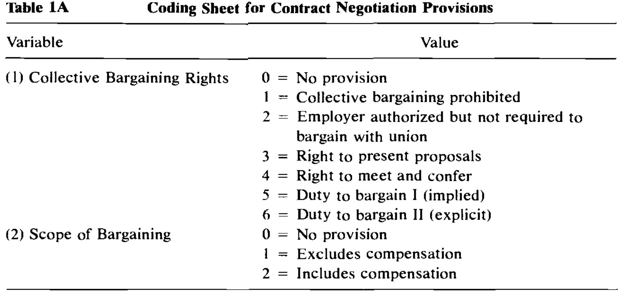
[Table 1A notes begin]
Notes: This section originally contained an additional variable, intended to represent the extent to which collective bargaining agreements were subject to legislative recall. After some preliminary coding, this variable was abandoned; consistent distinctions could not be made across different state laws.
Values 3, 4, 5, and 6 under variable (I) can sometimes be difficult to distinguish between. For 3 and 4, one needs to look for the key phrases; however, in both these cases the public employer is still free to unilaterally set the terms and conditions of employment (i.e., there is no obligation for the employer to actually bargain). Value 5 means that although there is no explicit statutory provision stating that the parties must come to an agreement, it is implied (frequently through specifying a ratification procedure or through listing failure to bargain in good faith under “Unfair Practices”) that they must attempt to do so. Value 6 means that there is explicitly stated (frequently in the definition of “collective bargaining”) an obligation for the parties to come to a written agreement.
[Table 1A notes end]
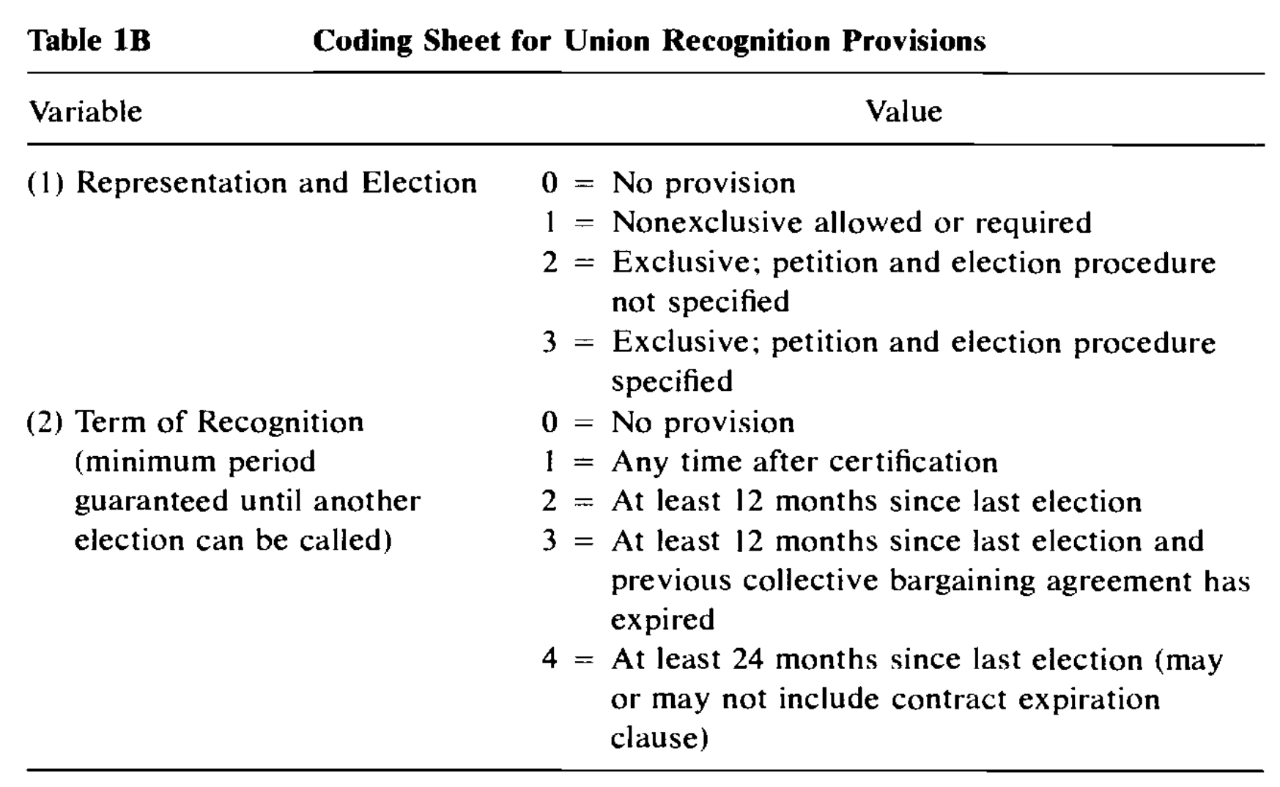
[Table 1B notes begin]
Notes: The election procedure specified typically includes provisions for the following: initial petition for certification (percentage necessary for acceptance, usually 30 percent), additional petitions to appear on ballot (usually 10 percent of members of bargaining unit must sign for organization to appear), posted notices, timing of election and other procedures, place of election, restrictions on who can vote, employer or employee organization noninterference, and runoff elections.
“Nonrepresentation” is invariably a voting choice. and certification can be legally revoked during the term of recognition.
Petition and election procedures can generally be avoided if the public employer voluntarily recognizes an employee organization and there is no challenge.
Despite exclusive representation, most laws contain a clause stating that employees can individually present grievances (although a union representative frequently must be present).
[Table 1B notes end]
The longitudinal nature of the data set is illustrated by a comparison of tables 2A and 2B. Of the twenty-one states which had comprehensive strong bargaining laws in 1984, only twelve had strong bargaining laws for at least one group in 1969; of those twelve, only five had strong bargaining provisions for all five functional groups. Similar variation exists for states with other types of provisions. For example, Minnesota switched from “meet and confer” in 1969 for all five functional groups to strong bargaining rights by 1984, while Virginia changed from a “permissive” (value 2) status for four groups in 1969 to prohibiting collective bargaining for all five groups by 1984. In general, the trend is toward more pro-bargaining laws (see table 3), although anti-bargaining states in some cases adopted more explicit or stringent anti-bargaining provisions. Overall, there is enough longitudinal variation to perform both within-state longitudinal and panel investigations.
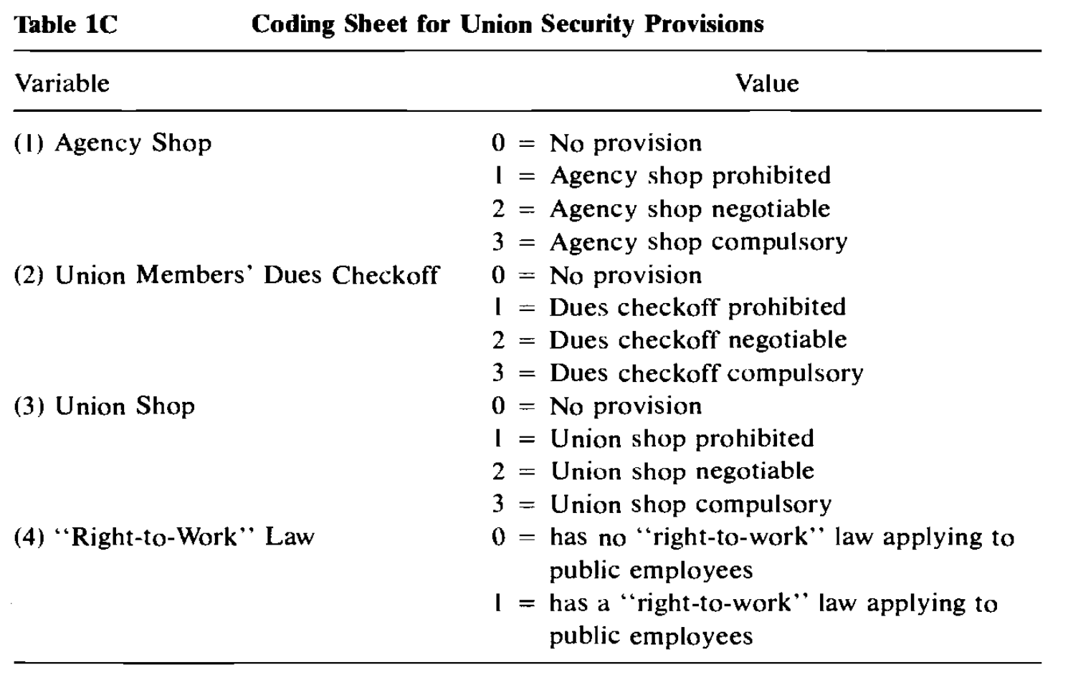
[Table 1c notes begin]
Notes: The term “fair-share agreement” is synonymous with “agency shop.”
Agency shop provisions typically stipulate that the service fee shall be deducted from nonmembers salaries. Such provisions are distinct from dues checkoff, which stipulates that union members’ dues shall be deducted from their salaries: the two types of provisions often exist separately.
“Maintenance of membership” is another type of provision relating to union membership; it stipulates that employees who join the union must maintain their membership for the duration of the collective bargaining agreement. We decided this was not important enough to code, although several states do have such provisions.
Agency shops, dues checkoff, and union shops are “negotiable” when the law stipulates that public employers and public employee unions may settle contracts that include such provisions. “Prohibited” and “compulsory” are self-explanatory, except that dues checkoff is also coded as “compulsory” when the public employer must deduct union dues at the request of either the union or individual employees. Also, individual employee consent is generally required by the law.
[Table 1c notes end]
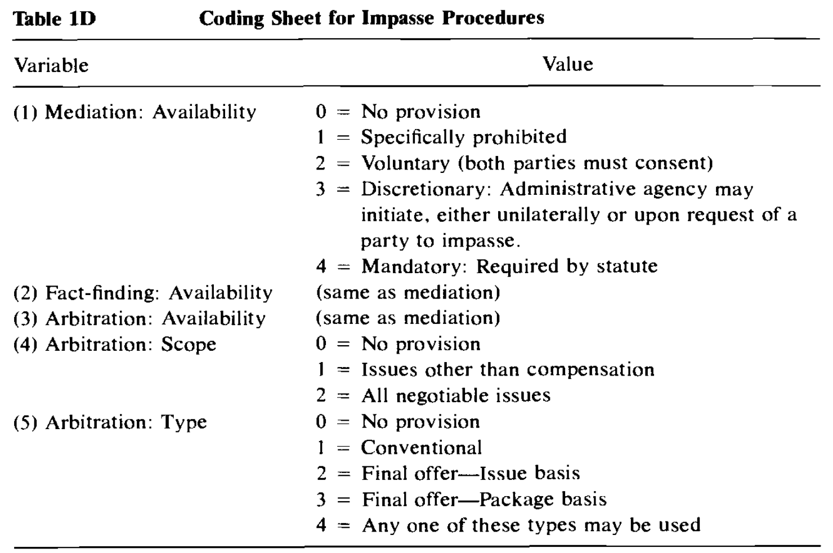
[Table 1d notes begin]
Notes: The coding is intended to reflect the actual nature of the process provided for in law and may in some cases differ from the wording used in the law where that deviates from common usage. For example, Alaska’s teachers’ law does not explicitly provide for fact-finding, but their so-called mediation process clearly includes fact-finding. The most important example of this is arbitration. We define arbitration as being final and binding. Some states have so-called arbitration procedures that are merely advisory, hence no different from fact-finding; we have coded such procedures as “fact-finding.’’
[Table 1d notes end]
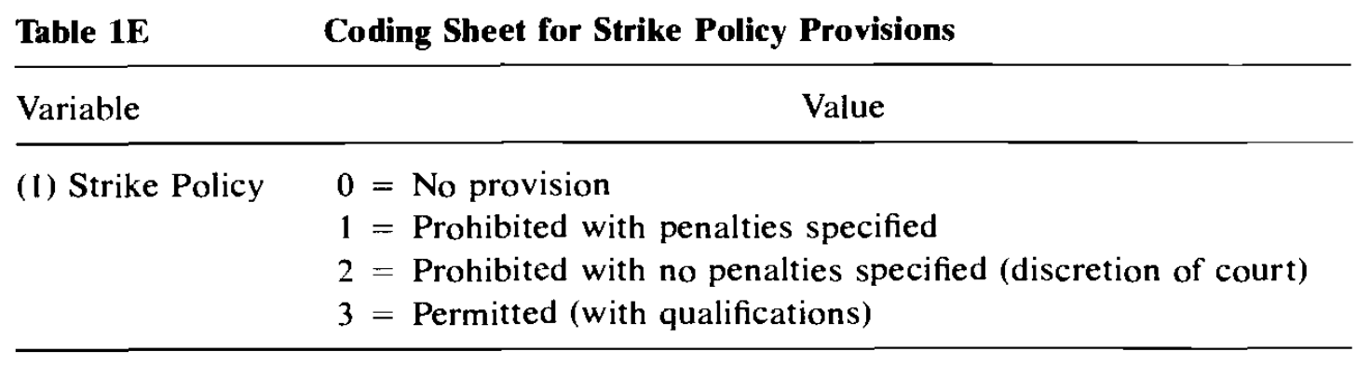
[Table 1e notes begin]
Notes: The values for this variable represent broad categories. However, the types of penalties and qualifications used are very consistent across states, and the values represent as fine a distinction between state policies as we are accurately able to construct from the laws. Researchers should note that depending on the state, court-imposed penalties may be more severe than those provided for by law.
In general, the penalties specified include one or more of the following: loss of union certification, loss of dues deduction, loss of wages during strike (or twice wages), termination of employment, fines for union and/or individual employees, and rehire on probation.
No state permits its public employees to strike without qualifications. Typical qualifications include: the previous collective bargaining agreement has expired and no new one has been reached; impasse procedures have been fully complied with; and at least XX days have elapsed since issuance of the fact-finders’ report. Such strikes can usually be enjoined if the courts decide that they have caused a threat to public safety or health.
[Table 1e notes end]

Vote neg:

1. Limits. Their interp explodes the topic to recognition, security, impasse, and strike-rights cases, multiplying affs across every sector and bargaining law type.

2. Ground — Our interp keeps the focus on the most prevalent and contested reforms in U.S. labor law---the bargaining process itself. Broader interps shift clash into recognition/strike literature with different political economic models.

CASE: RLA

Unions High---1NC

Rail union membership is high.
David Kemp & Peter Van Doren 23. Research analyst, M.S. in Applied Economics from Johns Hopkins. Senior fellow and editor of Regulation. Former instructor at the Woodrow Wilson School of Public and International Affairs at Princeton University, the School of Organization and Management at Yale University, and the University of North Carolina at Chapel Hill. “Understanding the Railroads-Unions Fight.” Cato Institute. Spring 2023. https://www.cato.org/regulation/spring-2023/understanding-railroads-unions-fight.
Compared to unions in other industries, however, rail unions remain relatively strong. As Table 1 indicates, union membership in rail, trucking, and airlines were high compared to other private industries before 1980. Whereas trucking and other industries saw a sharp decline in the 1980s and 1990s, rail and airline union membership (which are both governed by the RLA) remained at roughly 80 percent and 40 percent, respectively, into the 1990s. Today, union membership has decreased substantially but is still much higher for railroad employees at 54 percent, compared to 38 percent in the airline industry, 7 percent in trucking, and 10 percent in other private industries. Meanwhile, the railroad workforce sharply declined from 1973 to 2021, while the workforce in the other industries sharply increased. (Within some specific rail occupations, such as locomotive engineers, union membership rates remain even higher, at nearly 80 percent in 2021. But even in those occupations, both union membership rates and the total number of union employees have shrunk in the last four decades.)
Relative to other industries, rail unions likely benefited from the profitability and consolidation generated by deregulation, as well as their treatment by the RLA. First, in theory labor unions have more bargaining power in oligopolistic industries that have barriers to new entrants. Unlike the consolidation seen in the post-deregulation railroad industry, deregulation made trucking highly decentralized. Second, the decentralization and increased competition in the trucking industry led to decreased profitability for trucking firms. Meanwhile, rail profitability, driven by more shipments of coal, chemicals, and intermodal freight, increased. Finally, the RLA’s creation of nationwide bargaining units and emphasis on keeping the status quo may have allowed rail unions to hold onto more power, slowing their decline. In contrast, truckers’ unions, governed by the NLRA, are at the establishment level and were weakened by non-union competition.

On Case
Morrisey 24 (Evan, Stamps scholar @ UMiss. BA in Public Affairs, Public Policy and Public Administration from the University of Mississippi. Thesis under the guidance of Kyle G. Fritz, associate professor in the Department of Public Policy Leadership at the University of Mississippi. Ph.D. in philosophy from Florida State University. Second Advisor is Jarod Roll, professor of history at University of Mississippi. Third Advisor is Rebecca Marchiel who is an assistant professor of History at University of Mississippi. Ph.D. in United States History from Northwestern University. "An Investigation of Alternative Strike Policies for Railroad Workers." University of Mississippi Sally McDonnell Barksdale Honors College Honors theses. April 24, 2024 edited for type in brackets: []).
The AFF argues that because strikes have worked in other countries that they will be effective in the U.S. as well. Well, lets go line by line through the 4 countries listed.
First is Canada, Morrisey 24 says that
They also won wage increases of 8% over three years, a CAD $1000 ratification bonus, and an increase of the lifetime health and welfare payout cap from $60,000 to $75,000 (Meunier, 2020). However, the president of the Teamsters Canada Rail Conference still stated after the negotiations that, “the core problem of fatigue in the rail industry can only be resolved through government regulations.” Shortfalls were still apparent in the contract, and while companies have taken some actions, they still refuse to recognize rest and fatigue as safety issues (Ibid). While pressure primarily on the company's finances was high, the union was not able to fully address its greatest safety concerns.
Although the strike did increase wages in Canada, it did not increase safety concerns that the Union had. Considering that the AFF wants to convince us that strikes would lead to improvements in safety, especially safety in the automation sector, a failure here is a failure to support the AFF argument.
Next is France, where a strike occurred and appeared to be successful however, as
Morrisey 24 says
It is important to note that this specific high-visibility strike was only possible due to a loophole in French law. Normally the requirement that parties are to be notified 48 hours prior is legally enforced, and strikers who do not follow this procedure can face disciplinary measures (Guedes, 2018, p. 4). Additionally, as discussed previously with the 2018 rail strike in France, there are minimum service requirements that mean even if some workers walked out on a wildcat strike, other non-striking workers can be requisitioned by the government to provide what local officials deem as minimum service. The short duration of the strike means that the economic damage was very limited and thus difficult to calculate. A six-hour stoppage of one rail line primarily affects the commuters who are suddenly stranded. The greatest damage was in terms of distress and anger caused to consumers who were without immediate alternatives to using the tunnel to cross. People did not learn about the strike until they arrived at the station to find their trips canceled.
Wildcat strikes are a very full expression of workers' right to withhold labor. It is an expression of this right with no inhibitions; all the workers protest the conditions of their job without jumping through any of the government or union hoops. The indicators of how the pressure was made during the French strike mirror that of the Pullman strike. The economic cost to Eurotunnel was not very high, but only because the strike lasted less than a day. Many of the day’s trips had to be rescheduled, but costs did not extend very far beyond this. If the strike had lasted longer it could have had a much greater impact. In regards to reputation, both the union and the company suffered. The union was the source of most consumer ire since they had not previously announced the strike (Williams, 2023). Nevertheless, common sense would suggest that there was some impact on company reputation due to the strike creating doubts in the company’s ability to provide consistent service between England and France.
This strike is an anomaly in the French rail industry, and proves neither that strikes are on average effective in the French nor are applicable to the U.S.
Now for the next two countries, German Rail and U.K. rail. These two strikes were done under government interference. They were both classified as short strikes
, in the German rail system the usage of short strikes has been widely documented. The years after the war in Ukraine have been particularly fraught with industrial action. The German train drivers’ union, Gewerkschaft Deutscher Lokomotivführer (GDL), has gone on four strikes over the past six months, with two one-day strikes occurring in 2023, a three-day strike in early January, and a five-day strike most recently (DW, 2024b). During the strike some limited services were still provided, with long-distance trains running at 20% capacity (Tagesschau, 2024). The brief nature of the preliminary strikes is worth evaluating in terms of limiting the impacts of the strike while gaining some form of negotiating leverage. One-day rail strikes in Germany do not have the same stacking effect as longer strikes. Economists have offered that “the losses are likely to be limited to the transportation industry because factories will continue to operate and many employees will be working from home” (Marsh & Williams, 2023). These warning strikes were followed with further threats from the unions to continue expanded industrial action in the future. Estimates from economist Michael Groemling, head of economic affairs at IW Koeln, are that one day of a rail strike could cost the economy 100 million euros (Martinez et al., 2024). He specifies that this estimate comes from the direct losses to Deutsche Bahn and its partners, disruptions to the manufacturing and agricultural sectors, and losses of consumption and services due to the industrial action (M. Groemling, personal communication, January 29, 2024). The majority of the costs are contained within the industry or in closely dependent industries. The exact breakdown of these numbers is not available, and Mr. Groemling states that the economic costs increase exponentially during the span of the strike. The most recent example of the five-day strike of GDL workers is still yet to receive any greater economic analysis. However, it can be presumed that his estimates provide insight into the prior industrial actions by GDL in 2023. The pressure of the strike was limited more acutely to the transportation industry, due to its short nature. DB faced high economic pressure to move on demands. Since strikes were kept short, exponential economic impacts to the economy as a whole were limited. Instead the economic pressure in the instance of the short strike was directed at DB. The impact to DB’s reputation was mixed. Some consumers reported frustrations after multiple short strikes (Ziady, 2024). At the same time, the union went after the DB, claiming public opinion on its side as the strike was fighting, “so that this rail system is healthy and the people who work there can stay healthy for a long time” (DPA International, 2024). The total picture of German public opinion on the strike is unclear, but with a culture more permissive of strikes than the United States, more people seem willing to bear these costs. Pressure from the short strikes was spaced out and it was only after the last round of strikes in January that the company was open to negotiations. The strikes had started back in 2023. In terms of concessions after multiple strike waves Deutsche Bahn (DB) has finally struck a deal with the union. The operator most importantly agreed to a 35-hour work week, allowing workers to choose whether they want to continue to work 40-hours for more pay or 35-hours for the current base (DW, 2024a). Getting concessions on the work week had been the primary sticking point. The leader of the GDL, Claus Welskey, said that, “DB's willingness to negotiate a reduction in working hours for shift workers is of central importance” to avoid future strikes (DW, 2024b). In addition, DB agreed to one-off inflation bonuses: €1,500 in March this year, and another €1,350 in May (DW, 2024a). Pay will go up as well as a result of the strike: €420 monthly in two stages, €210 as of August 1 this year and another €210 as of April 2025 (Ibid). Evaluating the pressure of German short strikes shows that workers were able to capture significant concessions despite the intransigence of DB in prior negotiations. The pressure felt by DB primarily through high short-term economic costs and a damaged reputation meant that it finally came to the table to discuss the issues the union had fought for. Short strikes have also taken place in the United Kingdom
Why does this invalidate the AFF’s argument? Well, Morrisey 24 says
That “I divide the evaluated strikes into two umbrella categories: unrestricted and restricted strikes. Unrestricted strikes, like the name implies, have no limits imposed on them by the government. Workers can walk off as long as they want where they want. Restricted strikes are industrial actions that have government limitations. The limitations that I will look at for these strikes are participation, duration, and strikes that mix these limits. 4.1.1. UNRESTRICTED STRIKES The first and most common type of unrestricted strikes are open-ended strikes in which all workers walk off the job. These strikes are indefinite until terms are met in the negotiating room. The summer of 2023 was marked by the Writers Guild of America strike, which took five months and saw 11,500 union members participate (Barco, 2023). There was a full stop on all live shows, movie and TV scripts as all workers left the job and did not return until a new contract was hammered out between management and the union. Next are wildcat strikes. These are like open-ended strikes in that all workers walk out of a workplace to cease their work, but they happen spontaneously. The distinction is that economic strikes like that of the UAW are legally recognized as legitimate by the government. The union leadership called for a strike vote, the workers voted to strike, and when sufficient changes were not made at the negotiating table they struck. Wildcat strikes skip all of this and go straight to the strike. They do not have approval of the union leadership that generally makes the decision on whether or not the group should commit to a legally recognized strike. They are in a category to themselves. Last are “sickout” strikes. In this type of industrial action workers call out sick at the same time to give a cover to their wildcat strike. These actions generally last for shorter durations than a full-on wildcat strike due to workers only “striking” when they are out sick. They may or may not have the okay from union leadership. They are illegal in the United States, so even if a union suggested their workers call out sick they would not admit it for fear of legal liability.
4.1.2. RESTRICTED STRIKES There are three main types of restricted strikes discussed in the literature: participation limited strikes, limited duration strikes, and mixed strikes. Mixed strikes use some combination of restrictions on participation, and duration. The selective strike is when workers strike a certain company out of a multi-employer bargaining group to win better concessions and force other companies to concede to these terms. Particularly in the realm of railroads, this allows unions to adjust the participation levels by striking workers of certain train operators. Short strikes for a few days can be used as “warning shots” against companies to bring pressure in negotiations. In the US these are common among healthcare workers who cannot strike for prolonged periods; the recent strike of Kaiser Permanente by nurses lasted for only three days (Isidore, 2023). These strikes are heavily time restricted, as workers are only able to walk off for a limited amount of time. Intermittent strikes are when workers strike and then return to work on a periodic basis within one industry or company. This can take the form of a strike schedule, as is common when transportation workers strike in Europe, where the various strike dates for the month are laid out. How far in advance and how often a strike schedule is made depends on the union and relevant interests. Depending on the relevant government regulations, workers can notify the public even later about the strike. These strikes primarily rely on duration restrictions in which workers only walk off the job for a certain amount of time each week or month without losing their jobs. In the cases I look at there are variations in the participation levels of workers in these strikes, but participation is not a restriction. All workers could potentially participate in the strike; they are not prevented from striking from a policy standpoint. Rolling strikes are yet another variant in which a union calls for strikes but orders different types of workers to strike at different times or strike various employers in a multiemployer sector at different times. For example, signalmen strike on Monday, engineers on Tuesday, and dispatchers on Wednesday. Alternatively, workers could call for a strike on Norfolk Southern on Thursday and a strike on BNSF rail on Friday. The repetitive nature of these strikes builds pressure on companies to come to the negotiating table. These strikes use restrictions on the duration of the strike and the number of employees to limit the worker action. Rolling strike strategies may differ in which of these limitations is emphasized (in the example of striking multiple companies at different times, geographical restrictions are highlighted) but are a mix of all restrictions.
The short-term strikes, implemented in the U.K. and Germany, are examples of government restricted strikes, which is already the case in the Status, quo. The AFF wants congress to have a lassie faire approach to strikes, thus examples of government pressured strikes in other countries doesn’t prove that non-government intervened strikes will also be effective in the U.S. considering that in both cases, the government pressure forced union strikes to be more short term and sever.
Even if you don’t buy let’s look at an example of open striking, like the AFF suggests, but this time in the U.S. so it is more applicable. In New Jersey, Morrisey 24 finds that
Recently in 2022, locomotive engineers, a part of the Brotherhood of Locomotive Engineers and Trainmen (BLET), organized a sickout on Juneteenth. Hundreds of engineers called out sick: 205 on Friday, 143 on Saturday, and 133 on Sunday. This caused hundreds of trains out of New Jersey to be canceled (Wilson, 2022). A judge quickly issued an injunction ordering the union members back to work (Ibid).
In terms of economic impact, the short and limited nature of the strike makes it hard to estimate. The economic impact could have potentially been much higher if the strike had gone on for longer. The severity of the economic costs is part of the reason for the government intervention. The New Jersey Transit authority stated that 100,000 commuters use the service every day, and while the strike limited rail service, some trains still ran (AP, 2022a). At the very least, thousands of people had their travel plans temporarily interrupted. Some level of substitutability existed as passengers whose trains were canceled were given free fares on bus, light rail, PATH trains, and ferries from the city (Ibid). While the union officially maintained that it did not call the strike and that members choose to call off by their own violation, the National BLET paid the transit authority $50,000 as a settlement (NJ Transit, 2023). NJ Transit is still pursuing further legal claims against the union local.
The pressure generated by the strike ran into swift roadblocks. The direct economic costs to NJ Transit were largely limited by the short duration and incomplete participation of the strike. Many trains were canceled, but some were still running. It is worth noting that even before the sickout action the regional rail system was known for numerous canceled trains a week (BLET, 2023a). The reputational cost was twofold: aggravation with union workers who did not announce the strike prior, and further discontent with the NJ Transit authority that had pre-existing reliability issues.
As we can see, both modes of pressure were largely moot; this meant that the willingness to negotiate by the government was largely null since the action was quickly ended via injunction. The same goes for concessions. Workers did not end up winning any of their concessions, although at the very least some of the workers were able to exert their pure right to withhold labor and strike. The union is still working without a new contract in effect. They had struck on Juneteenth not only to make a point about more paid days off, but also because the wages of train engineers in New Jersey were much lower than surrounding operators. The absence of wage increases had caused massive staffing shortages, meaning canceled trains were commonplace in NJ even before the sickout. Wage increases still have not appeared. The union instead is pursuing further industrial action. BLET put out a press release that 81% of the union had voted to go on strike (BLET, 2023b). This strike faces the same obstacles in the RLA that precluded prior rail strikes, but it shows that the union still sees industrial action as the only way for it to push the hand of the state transit authority to offer competitive wages for the region. While the sickout did not facilitate sufficient protections of workers’ rights, the union is seeking further action to achieve it.
Sickouts are an example of workers trying to find a middle ground: still a wildcat strike, but with a legal cover. Modern examples show that they can be effective in expressing discontentment of workers, especially when they lack alternative industrial actions codified by law. The economic cost of the disruption is limited because not all workers call off sick, some services are still provided, and they last for short periods of time. However, their random nature means they are hated by companies and the government. Often, they do not bring enough pressure to the negotiating table. Even though NJ Transit workers walked out in 2023, they still do not have a contract and are trying to legally strike this year.
Wildcat and sickout strikes create the highest degree of burden out of the unrestricted strikes due to their total lack of notice. They incur higher economic costs since companies cannot prepare ahead of time. They can also anger consumers much more because they are not notified ahead of time and cannot plan for the industrial action. However, due to the high level of pressure they exert, they allow workers to put maximal pressure on the negotiation table. Workers can exercise their right to strike in an uninhibited manner. Since the pressure is so great, however, it can result in direct government repression of the strike to end the economic harm. They suffer the highest likelihood of government intervention save for unique circumstances.
In the U.S. using forms of open strikes are much more difficult as seen in New Jersey, especially since areas of the U.S. with rail tend to have many alternative modes of transport, more so than other countries.
Now let’s take it a step further, you can actually turn this argument to show why you should not implement the AFF plan. The AFF argues that collective bargaining should be strengthened so that in the case of a war, we have the ability to transport supplies and troops. However, giving rail workers the ability to strike at any moment like the AFF suggests only puts the U.S. at risk of a strike during war time. Especially when danger and tensions are high its possible that workers strike during a time when rail services are needed.
Morrisey 24 continues that
Wildcat strikes have some of the largest economic impacts but moreover cause wide public discontent because of their lack of prior warning. For workers on the job, it is a question of strategy to use a wildcats strike to leverage management. However, for consumers who suddenly cannot access the goods and services, it is a question of why suddenly there are massive shortages. Workers are faced with the question to what extent they want to sacrifice the versatility of the strike action. Thus, there is not much recent economic data on prolonged wildcat strikes. Wildcats do not even always succeed in their initial aims to protect worker rights as the government often intervenes to break the strike. Wildcats may seem like the highest pressure strike, but the backlash often impacts the workers the most. The company has less incentive to give into demands, and so the pressure created might be less than in open-ended strikes.
Moving on to their Compass 23 card,
Even with the AFF’s adjustment to rail workers’ ability to strike, their own card proves that the U.S. has other counter measures to enforcing the current provisions under the RLA, via the Taft- Harley Act which
Compas 23 (Lance, Senior Lecturer Emeritus at Cornell University’s School of Industrial and Labor Relations in New York. J.D., Yale Law. “US Labour Law and the Right to Strike” International Union Rights. International Centre for Trade Union Rights Volume 30, Issue 1, 2023 pp. 9-12)
also set in place an “emergency” mechanism based on the Railway Labor Act model. It empowers the President to create a “board of inquiry” to determine if a looming strike or lockout would disrupt interstate commerce or “imperil the national health or safety.” The board can recommend that the President seek a federal court injunction to halt the strike or lockout. Presidents have done so more than 30 times since 1947, usually in connection with potential strike action that would shut the nation’s ports. Only once did a court deny the President’s request for an injunction.

- Amende the RLA but do not change the mechanisms of the government (tuff tarley act) in the cross – means that the government still have the power to shut down unions – no solvency

